**FSAE Tire Temperature Visualization**

**ECE3220 Final Project**

**Spring 2017**

**Max Houck**

**Marshall Lindsay**

**Abstract**

The goal of this project was to aid in the interpretation of key tire temperature data during the design of Mizzou Racing’s Formula SAE car. This data is used extensively during the suspension design and gives the engineers qualitative information to make the correct decisions. The current problem lies in the ability to interpret this data in its raw form. Thousands of data points, some completely invalid, are almost impossible to make sense of without any form data processing. Discussed here is our solution to this problem. By using signal and data processing, combined with an intuitive graphical interface, we’ve created a software package that not only allows engineers to interpret this raw data, but leaves room to be extended to real time telemetry.

**Introduction**

Formula SAE is a collegiate engineering team where students design and manufacture a quarter scale formula-style racecar. This racecar is built to compete in both static and dynamic events against other collegiate teams across the globe. During the design process, engineers rely on data acquisition to validate and optimize critical systems to maximize safety and performance. A portion of this data includes tire temperatures.

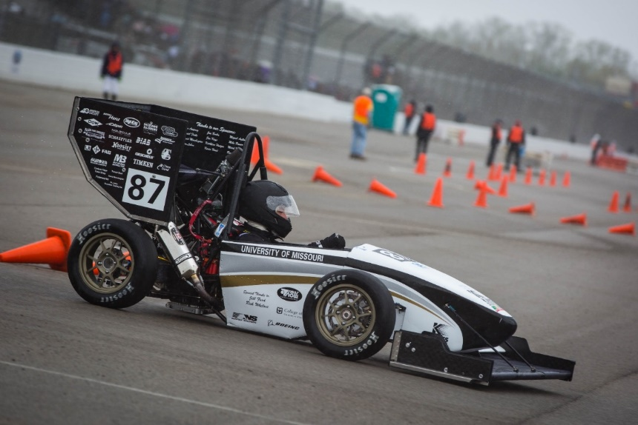Tire temperature data is used extensively during the design and optimization of the racecars suspension system. Proper tire data allows engineers to ensure there is optimal energy transfer from the car to the ground. The Mizzou Formula SAE car is outfitted with twelve infrared tire temperature sensors (three per wheel). The data from these sensors is read by four AVR microcontrollers, via I2C serial communication, mounted at every corner of the car. This data is sent over the racecar’s CANBUS to an onboard datalogger that outputs the data to an SD card. After a test drive, this data is used to validate suspension design. Currently the data is viewed in its raw form; thousands of numbers representing degrees Celsius at different points in time. In this form, the data is nearly impossible to interpret. The aim of this project was to process and display this data in an easy-to-interpret heat map allowing engineers to make proper optimization and design decisions.

*Mizzou Racing’s 2016 Competition Car*

**Background**

Tire temperature data is an important metric for Formula One teams around the world. This data shows how efficiently the tread of the tire is being used to transfer energy from the car to the ground. Ideally, equal temperatures should be maintained across the entire face of the tire. Hot or cold spots represent poor suspension design or tire defects. There are currently high-end racecar data analysis software packages for sale, however these are extremely expensive and often not customizable. By developing our own software packages for visualizing tire temperature data, we can meet the current needs of the team while simultaneously creating a robust foundation to expand upon in the future (several more data channels could be added for visualization purposes).

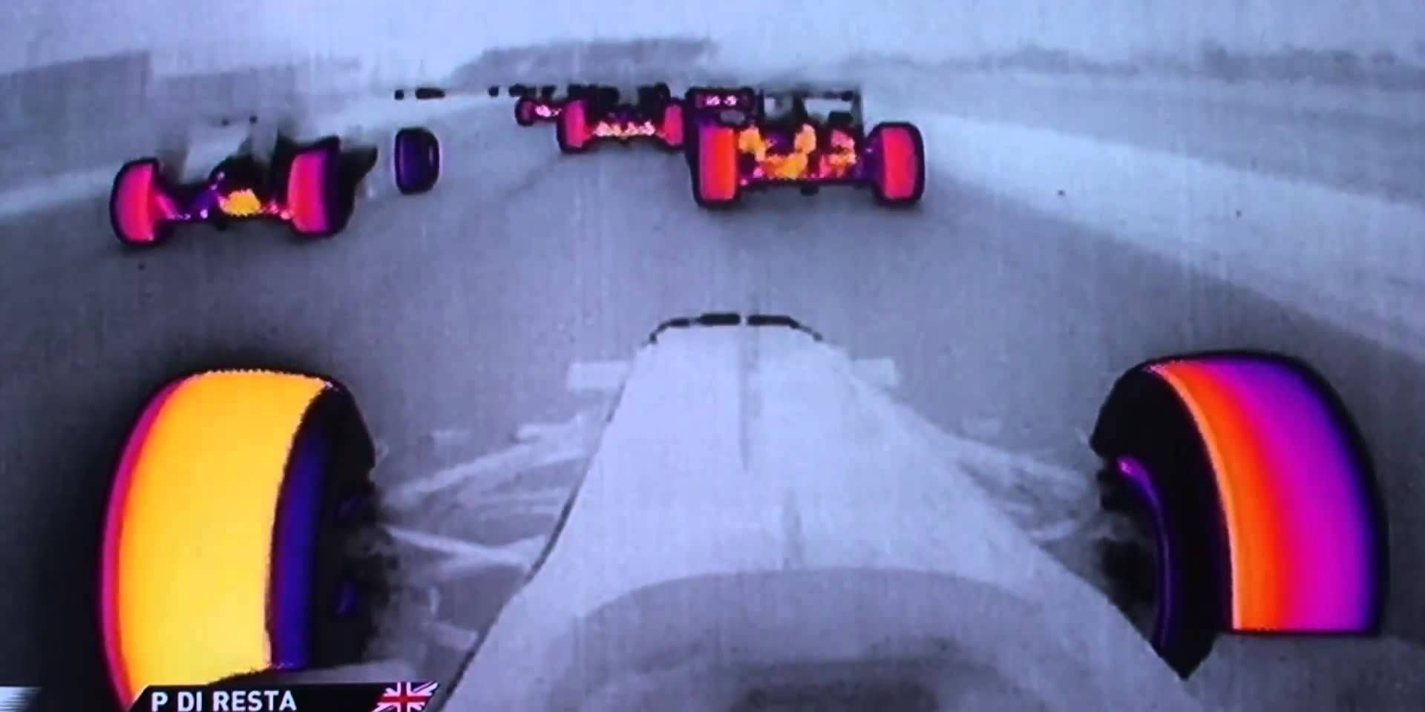

*Formula One Tire Temperature Cameras*

**Implementation**

The program is broken down into three major parts: 1) the processing and storage of data from files, 2) reading data from serial bus and 3) the graphics. The relationship between the three parts is shown by the Class and Use Case diagrams below.

Logged data was read in via text files whose contents consisted of three columns of numbers. Each column represents a temperature as it was recorded by the datalogger. A screenshot of this data is shown below where the leftmost column corresponds to the outer sensor and the rightmost the inner sensor. Four files are required to run the program, one file for each of the tires.

Each data point is added to the corresponding Sensor class temperature vector. There, the data is stored until it is used for graphical representation. The class hierarchy used creates a logical organization of data making access and modification simple and effective.

During the creation of the graphical interface, we opted to use filled rectangles to represent the four different tires on the car. These rectangles would be filled with a temperature gradient resembling an infrared heat map. Extra care was taken to insure the graphical interface would be extendable to a wide range of applications in the future. Customizability was also a major consideration, leading to a graphics interface that can be adjusted during run time.

A text-based menu system was created to allow the user to interface with the various systems and controls. These menus allow the user to choose between real time or logged data representation and to change the location and size of the various graphical entities. Exception handling can be found throughout the program keeping the program safe from erroneous user input.

The real-time interface was constructed as a basis for a more advanced telemetry system that may be implemented in the future. This system would need to consist of a fully wireless interface to interact with the car as it drives. Because this exceeds the scope of this course we opted to design the foundation to be added upon later. This foundation consists of reading data from the sensors in real time using an Arduino and then sending that data to our workstation via serial communication. This data is read, processed, and sent to the graphical interface.

When accessing the data in real time via the serial bus, data is not stored (except for a small buffer used for signal validation and processing) but sent directly to the graphical interface. This choice to bypass all storage leads to an almost perfect real time graphical representation. The choice to read data in real time comes with some problems that have not been fully addressed. These problems will be discussed in detail during the Experiments and Results section of this report.

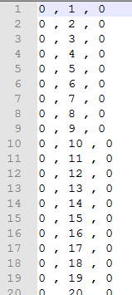

*Screenshot showing data from file*

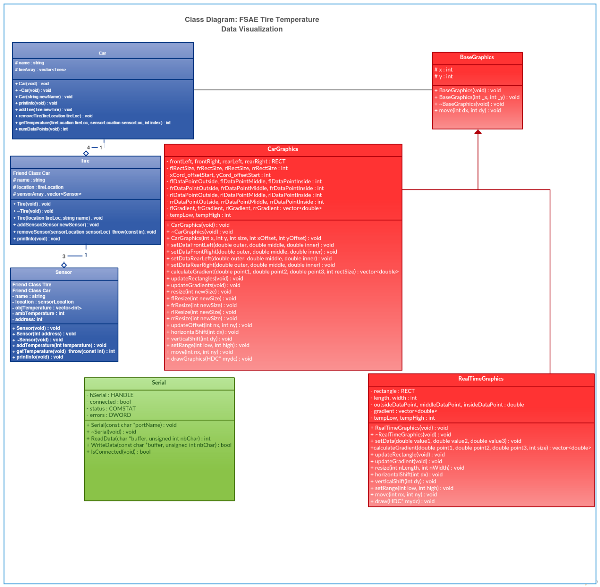

*UML Class Diagram*

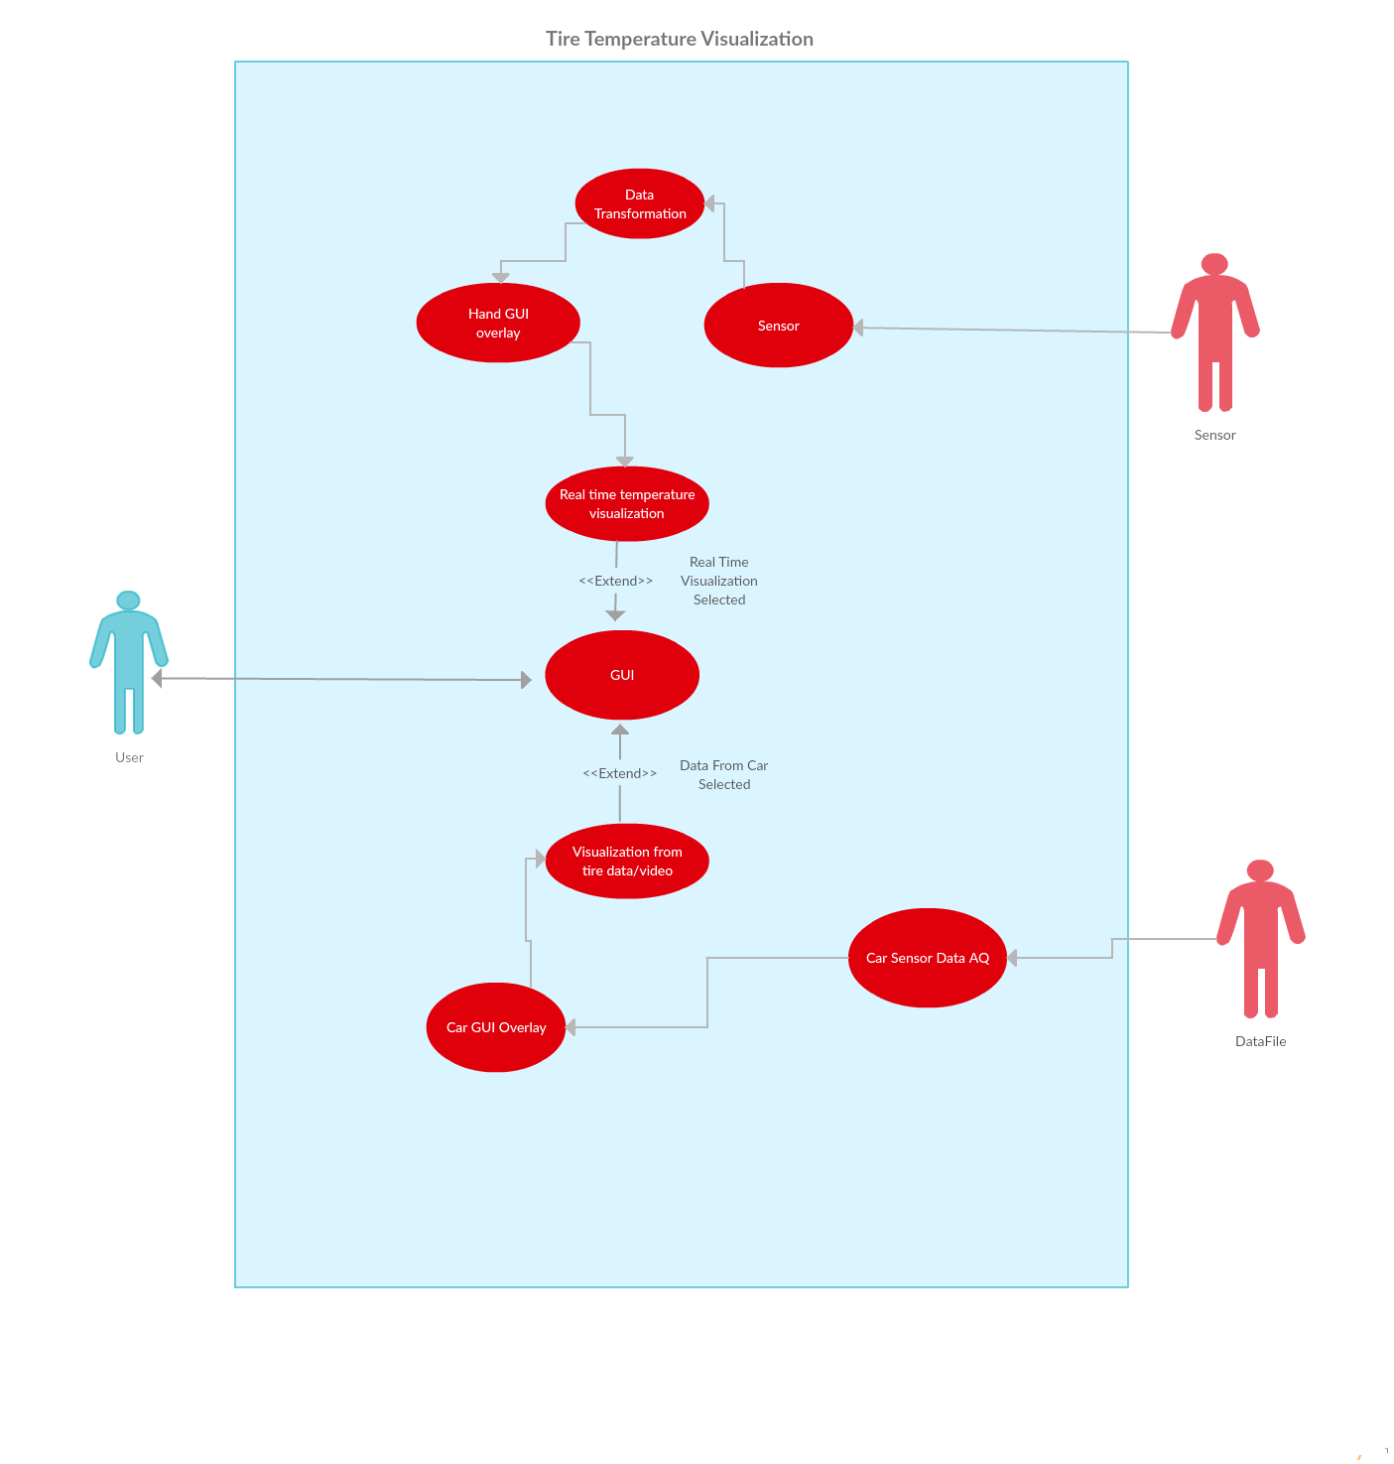

*UML Use Case Diagram*

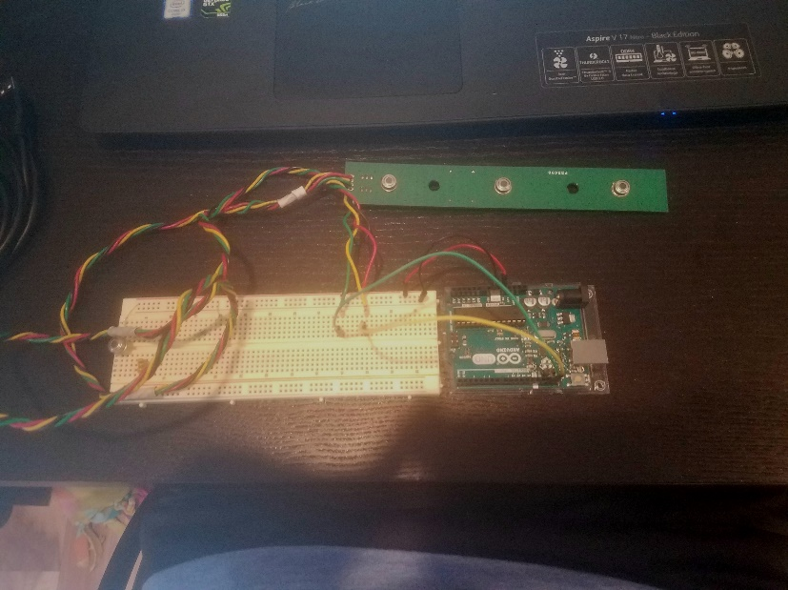

*Picture of Arduino and sensor setup*

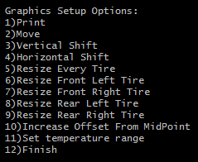

*Screenshot showing one of the option menus found in the program*

**Experiments and Results**

This project was consistently put through various tests during the design process. Several of these tests involved the graphical representation of data. The starting point for the graphics was a simple filled rectangle shown below. Initially this was done by setting the colors of individual pixels within the confined area. This proved to take too much time (around one second for a 100x100 pixel box) and would not allow for high speed data visualization. After some research, another function was found in windows.h, FillRect. This function took a pointer to the console handle, a pointer to a RECT object, and a brush set to the desired RGB value. When given a 100x100 pixel rectangle to fill, this function finished instantaneously.

While the use of static colors is useful, it was not what we envisioned for the project. We wanted to see a dynamic heat map across the tire. Naturally the next step was to create a color gradient. This posed a problem given our current knowledge and tools for creating graphics. The function we were currently using took rectangle with fixed dimensions and filled it with a fixed color. We needed to develop a way to create a seemingly dynamic graphics package with completely static tools. This was achieved by breaking down the rectangle we wanted to fill into columns of pixels. Then, by filling each column of pixels with a slightly different color, we could achieve a “dynamic” color gradient.

Three different gradient production algorithms were created and tested to achieve the intuitive and pleasing heat map representation of data. These included a 510-linear interpolation, a 1020-linear interpolation, and a 510-quadradic interpolation*.* After several experiments, the 510-linear interpolation was picked to create the gradients inside the tire boxes. Each of these graphs and their outputs are shown below (Note: the 510-quadraic interpolation was not simulated due to problems with the way the program handled the squaring of numbers).

Always taking extendibility into account, the graphics were implemented with zero static qualities. Everything from the size of the boxes to the temperature scale within the boxes are customizable to fit the user’s needs.

The program was tested with a wide array of possible user inputs to check for valid exception handling. Perfect exception handling is found throughout most the program. Exception handling was not implemented fully during the graphical adjustment menus purely due to time constraints. If erroneous input is entered during these menus, the program will fail.

Reading data via serial communication created several problems that we have yet to fully solve; the main problem being signal processing. Some of the data received over the serial bus is completely invalid and leads to a graphical representation that lacks validity. This ‘garbage’ data was dealt with through rudimentary filtering using a five-data-point residual buffer. This buffer contains the last five data points whose average is calculated. If a new data value doesn’t correspond with the trend of the data, the data point is removed and replaced with the average. This filtering removes outliers in the data while maintaining data trends.



*Filled rectangle representing the starting ‘block’ for our graphical representation*

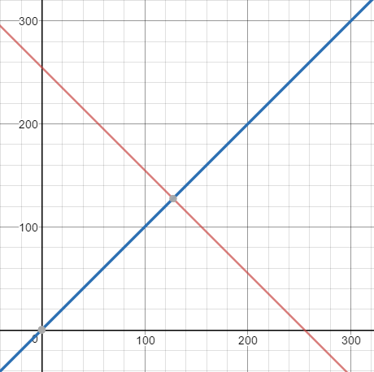



*255-linear interpolation of two colors*

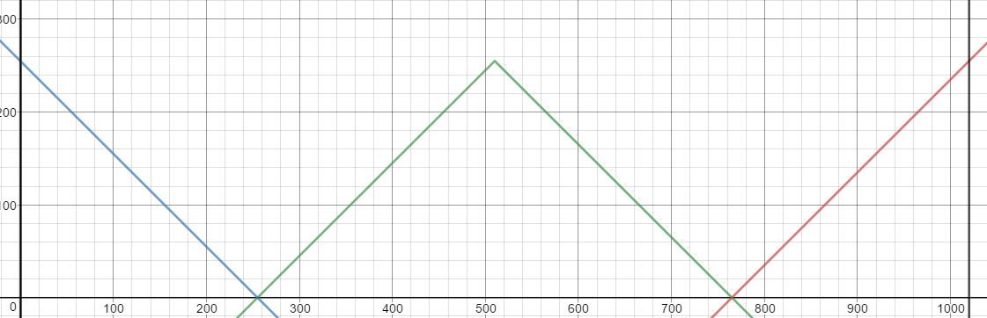

**

*1020-linear interpolation of three colors*

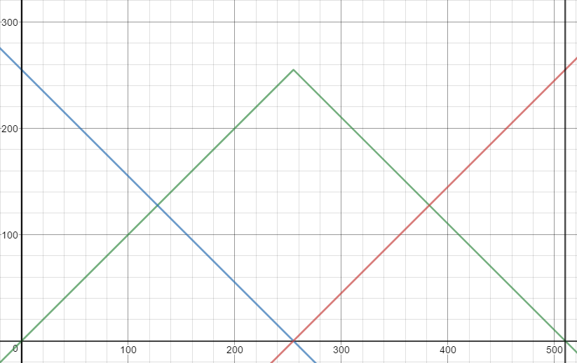



*510-linear interpolation of three colors*

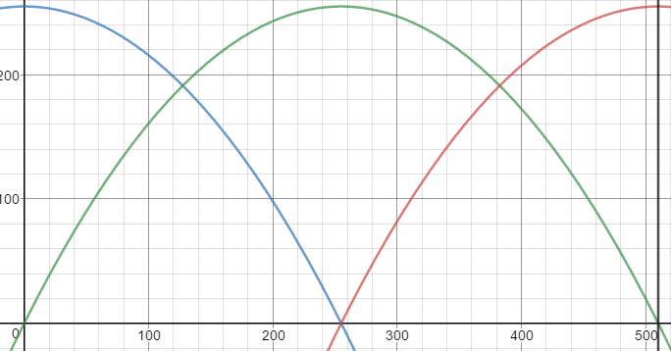

*510-quadradic interpolation of three colors*

**Discussion and Conclusion**

Throughout the design process, the layout and functionality of the program consistently changed. The UML diagrams helped to keep the project on track and our members on the same page. The importance of proper documentation, planning, and high level diagrams will only increase as we are exposed to bigger projects in the real world.

GitHub was used extensively throughout the development of the project. This was both of our group members first experience using GitHub as a collaboration tool and it proved to be a rewarding experience. The use of frequent commits lead to a workflow that kept both members working on up-to-date code and allowed us to roll back the code in the event a bug was introduced.

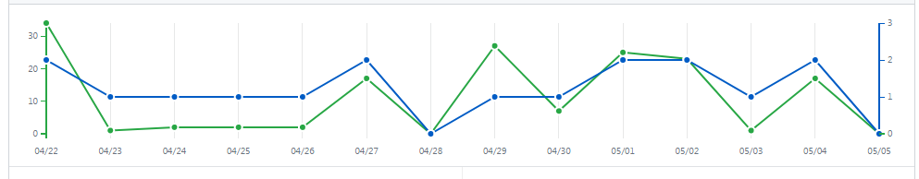

*GitHub activity*

This project pushed our knowledge of C++ programming to the limits. By the end, our project evolved from a simple idea into a solid foundation for future development by the Formula SAE team. Numerous features can be layered over our program such as reading data from a database or real time telemetry. We’ve created the starting block for future engineering students to expand and create.

**Code:**

